
Sweatshirt Orders
Swimmer’s Name:__________________________________________________________________________________Date:___________________

Parent’s Name:____________________________________________________________________________________________________________________

Practice Group: (Circle One) SRE SR2 SR1 PreSr3 PreSr2 PreSr1 AG3 AG2 AG1 Blue2 Blue1 Red White

Practice Pool: (Circle One) Aquatic Center Beaumont Colony Grant New Territory Settlers Park Seven Meadows

DESCRIPTION | UNIT PRICE | QTY | SIZE | TOTAL
SWEATSHIRT (Crew neck – Black) | $20 |  | Circle SIZE:  YOUTH : Small Medium Large  ADULT Small Medium Large XL  (Add $3 for) XXL XXXL
 |  |  | SUBTOTAL:
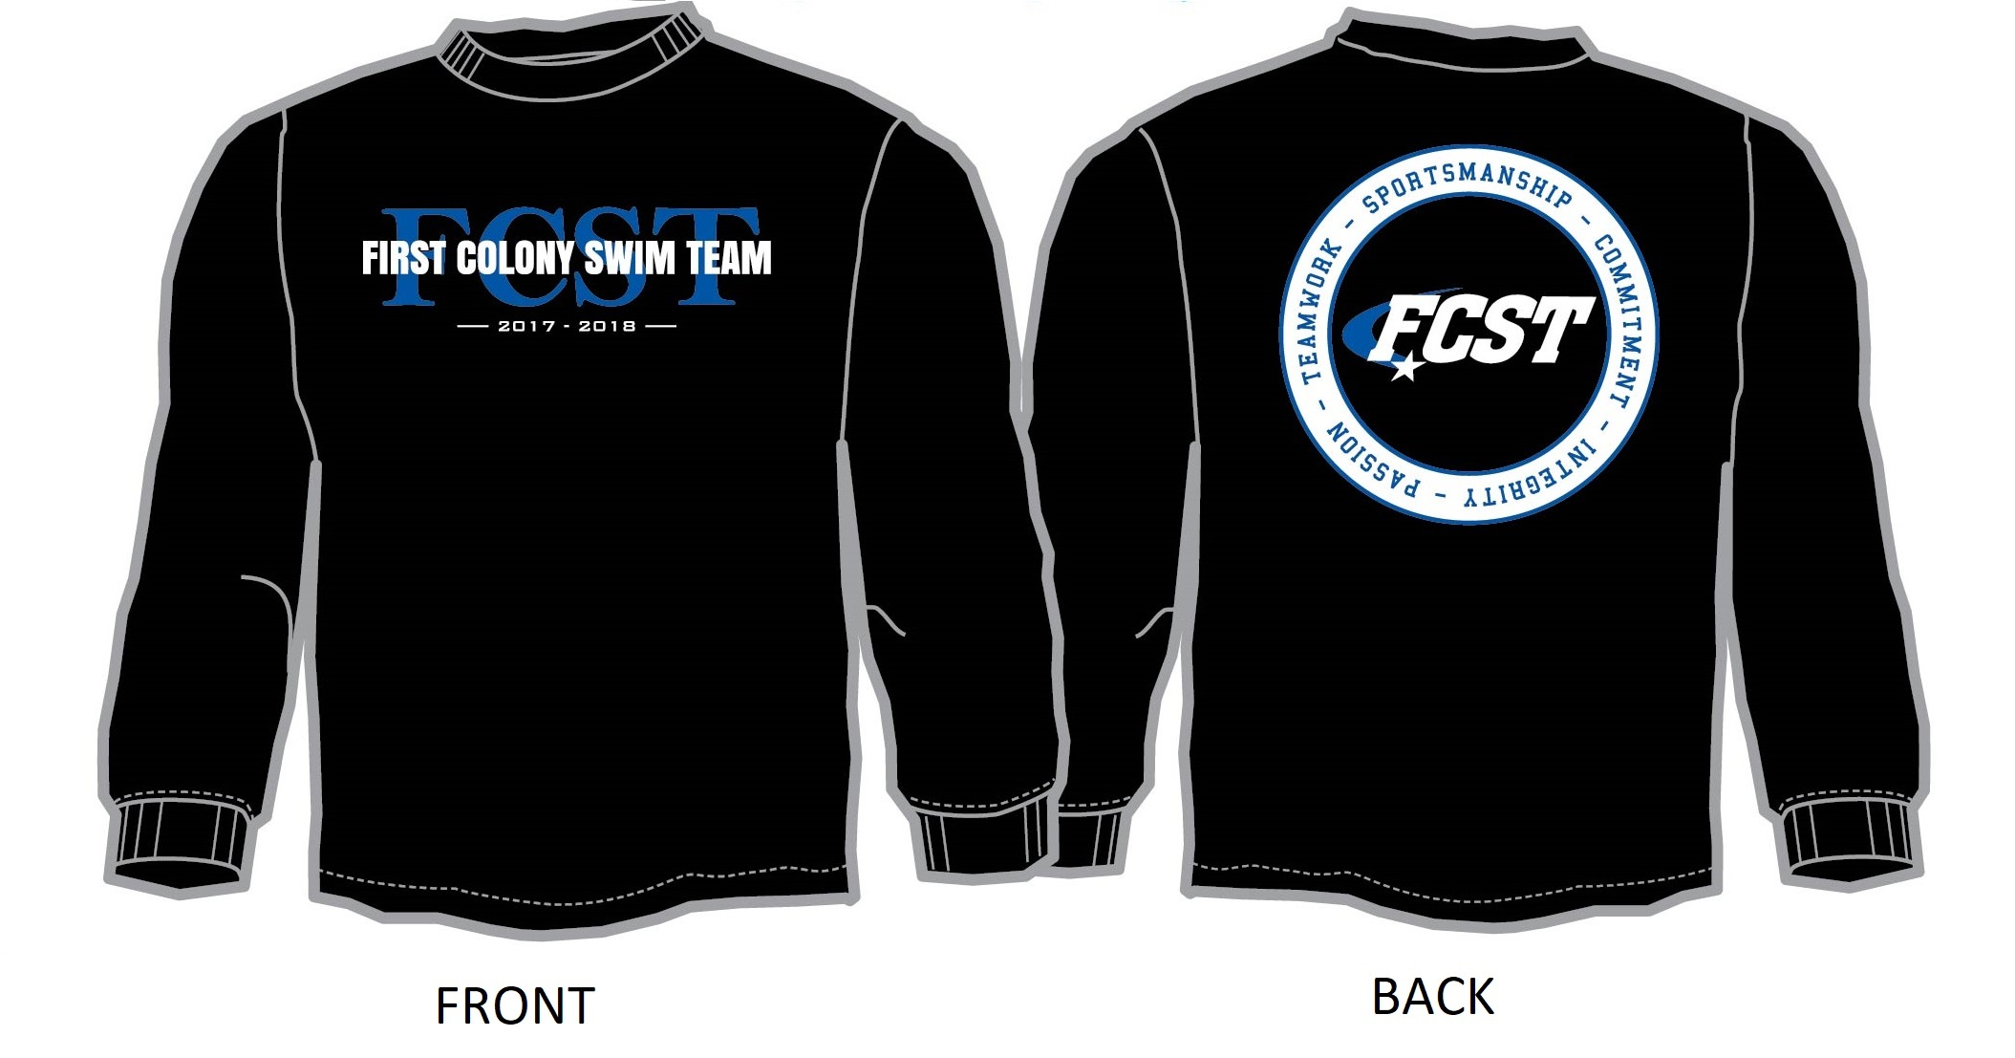 |  |  | SALES TAX (8.25%):
 |  |  | TOTAL:

PARENT SIGNATURE__________________________________________________________

PARENT EMAIL_________________________________________________________________

