Howdy Families,

I am so proud of our kiddos this weekend. They did phenomenal tackling their events- and the 500 to boot! What a testament to their mental and physical strength. I hope they all got a huge hug and high five from you celebrating all their hard work and mental toughness. GREAT JOB!

Last night, we reviewed the meet, DQs, and shared the things we were proud of. We also had a good discussion about the things the kiddos would like to focus on and review to help them meet their goals at the February Champs Meet. I always enjoy hearing their thoughts, and I think it’s great for their teammates to hear them, too!

12 & Under Champs will be February 20-22 at Don Cook. Girls will compete in the AM on Saturday and Sunday, and Boys will compete in the PM on Saturday & Sunday (for real, this time! Haha!) All athletes competing in the 200 IM & 500 FR will compete on Friday evening. I look forward to seeing what we can accomplish at the end of the season!

CONGRATULATIONS TO OUR SWIMMER OF THE MONTH FOR DECEMBER (COMMITMENT)-
MELIA COGILL!

FCST CORE VALUE OF THE MONTH (JANUARY): PASSION
Ambition materialized into action.
To put as much mind, body, and soul into something as possible.
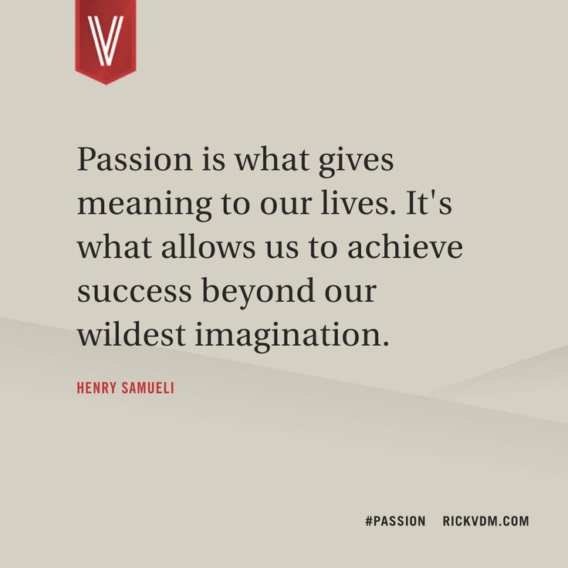

BLUE 1 SCHEDULE SHORT COURSE 2025-2026
Please check the Blue Group FC Webpage regularly for updates
Blue Group FC- Monday through Thursday 5:00-6:15 PM at Colony Grant 6 (CG 6)
- Saturday 8:00-9:15 AM at Colony Grant 6
- Please make sure your swimmer is prepared to get dry & warm quickly after we get out of the water. A towel is a MUST! Parkas are not meant to dry your swimmer. They are meant to keep them warm once they’re dry.
IMPORTANT DATES
- January 13th- Binder: Meet Review
- January 14th- Binder: Work Hard Wednesday
- January 20th- Binder: Get Tough Tuesday
- January 28th- Binder: Work Hard Wednesday

OTHER IMPORTANT SCHEDULING NOTES
- Spring Break- FBISD has moved their Spring Break this year, so it no longer coincides with KISD or LCISD
  - LCISD & KISD Spring Break– Practices will be offered Tuesday, March 10th – Wednesday, March 12th in the First Colony area
  - FBISD Spring Break– Practices will be offered Tuesday, March 17th – Wednesday, March 19th on the Katy/Richmond side of town
  - With the school districts having two different Spring Breaks, we want to offer practices during the middle part of each week. There won’t be practice on Mondays, Fridays, or Saturdays of those weeks.

PARENT EDUCATION
New Year’s Resilience by Swim Strong Dryland

Rather than solely focusing on outcome-based RESOLUTIONS, we believe the key to success is incorporating a process-based RESILIENCE. There are several things you can do to increase your resilience and ability to change:

- Set up an environment for success. Your environment plays a major role in how much friction there is when working towards a goal. As a swim athlete living at home, one of the best things you can do is team up with your parents/guardians. They are for you and want to see you succeed! Take a look at what types of foods are most readily available to you. Talk to your parents and make a plan to always have fueling/recovery foods on hand. Offer to help with meal/snack prep, grocery shopping, or list making. Check out our SSDL Grocery List for some inspiration!
- Add rather than subtract. One of the biggest mistakes people make when coming up with New Year’s Resolutions is trying to eliminate all the “bad” first. Research shows that focusing on adding in solutions first can lead to greater adherence. For example: Rather than eliminating all fast-food, use the Fast Food Menu Guide when you hit up McDonald’s. Rather than eliminating watching Tik-Tok videos in the evening, seek out videos that help you learn to cook/prep. Rather than immediately cutting out that pre-workout cookie, pair it with a cheese stick (or other protein source).
- Make time to evaluate/assess. Don’t overlook this important step if you want to become more resilient! Once you start implementing habits and processes, set aside a small window of time each month to evaluate how you are progressing. Ask yourself: Is this sustainable? How am I feeling, both mentally and physically? How would I rate my energy levels this month? How am I performing at practices? How’s my sleep been? And so on. You can utilize the SSDL Wellness Questionnaire as one way to dig into these types of assessment questions. If something you’re implementing isn’t working for you, don’t be afraid to adjust.
- Have a growth mindset. A growth mindset isn’t afraid to fail. In fact, it welcomes failure. Rather than comparing yourself to other swimmers or having a perfectionist mindset (one that is afraid to fail), keep the long game in view. The growth mindset knows that things will not always be easy. Things may even be more difficult now than they will be down the road. When difficulties arise, the only way to grow is to lean into the trial. Become flexible when things don’t go your way. Be open to new opportunities. Identify and work on your weaknesses. Resilience is our ability to recovery quickly from hardship and change.
As always, please feel free to reach out to me if you have any questions or concerns at all. I am always happy to help!

See you at the pool!
Coach Mandy

